Title of Extended Abstract
(Times New Roman, 14 pt, bold, capitalize each major word)

Presenter’s Complete Name ¹, Co-author Complete Name ², and Corresponding Author Complete Name ^{1,3,*} (Times New Roman, 11 pt, plain text; underline name of presenter and use asterisk for corresponding author)

¹ Department, Faculty/College, University/Institution, Address, Zip Code, Country (11 pt, italics)
² Department, Faculty/College, University/Institution, Address, Zip Code, Country
³ Department, Faculty/College, University/Institution, Address, Zip Code, Country

*Corresponding author: emailaddress@domain.com (Do not underline email address; Times New Roman, 11 pt, plain text)

ARTICLE INFO |  | ABSTRACT
Received (ICWES20)  Received in revised form  (ICWES20)  Accepted (ICWES20)  Keywords  keyword 1, keyword 2, keyword 3, keyword 4, keyword 5. |  | This template is intended for the preparation of the extended abstract for the 20th International Conference of Women Engineers and Scientists (ICWES20). Please follow this format carefully. The abstract should briefly describe the background, objective, methodology, key findings, and major conclusion of the study and should not exceed 300 words. Use Times New Roman, 10 pt, italic. For the keywords, provide a maximum of 4–5 phrases in lowercase, separated by commas, and ending with a period. Use Times New Roman, 8 pt, italic for the keywords.

- INTRODUCTION

Please use this template in preparing your ICWES20 extended abstract. The main body should be formatted in two columns. Use Times New Roman throughout, and Symbol font only when needed for Greek letters or special symbols. The body text should use 10-point font. The extended abstract should include the title, authors, affiliations, keywords and abstract, main body (introduction, methodology, results and discussion, conclusion), acknowledgment (optional), and references. The extended abstract must not exceed 3 pages. Authors are responsible for image quality and readability. Use Letter size paper (21.59 cm × 27.94 cm) with margins of top 3.0 cm, bottom 1.8 cm, left 2.5 cm, and right 1.5 cm. Paragraphs should be justified, with line spacing of 1.15 and a first-line indent of 0.5 cm.
For section headings, use Roman numerals starting with I. Example: I. INTRODUCTION. Leave one line after the section heading before the subsection. For subsection headings, use Arabic numerals, for example: 1. Materials and Reagents, 2. Modeling, 3. Effect of Temperature. Leave one blank line between major section headings and subsection headings.

- MATERIALS AND METHODS

- Materials and Reagents
For subsection headings, capitalize the first letter of each major word and use Times New Roman, 10 pt, plain text. No extra space is needed between the subsection heading and the first paragraph.
Define abbreviations and acronyms the first time they appear in the main text, even if they were already defined in the abstract. As much as possible, avoid abbreviations or acronyms in the title and section headings.

- Experimental Set-up
Figures should fit within a single column whenever possible. For large figures, the full page width may be used; however, the succeeding text should return to the two-column format. Figures must be clear and should not be crowded with unnecessary details and labels. Figures and images may be colored or black and white.

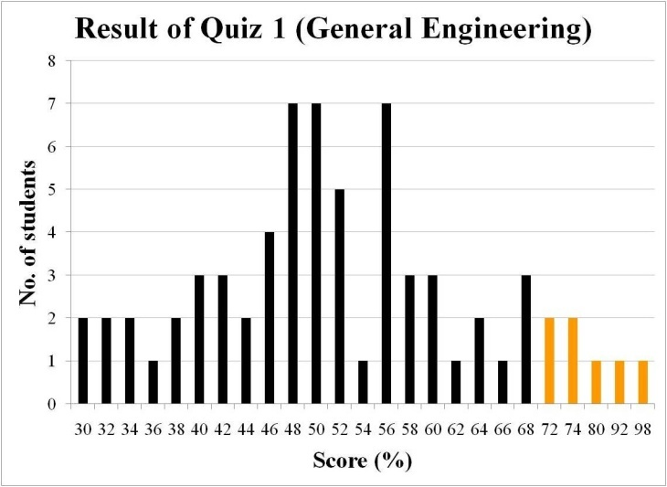
Figure 1. Sample result or graphical output.

Every figure must have a figure number in sequence (Figure 1, Figure 2, Figure 3, etc.). The figure number and caption should be centered and placed below the figure. Use Times New Roman, 9 pt, plain text. Capitalize only the first letter of the figure caption.

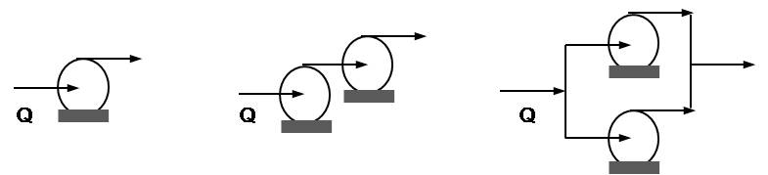
Figure 2. Sample process flow or equipment arrangement.

Cite figures in the text as follows: The variation of the ash components in the sample is shown in Fig. 2. As shown in Fig. 3(a), the particle size was reduced compared with that shown in Fig. 3(b). Each table should be preceded and followed by one blank line.

- RESULTS AND DISCUSSION

- Tables
For tables, place the table number and caption above the table and align them to the left, as shown. The table caption should use Times New Roman, 9 pt, plain text. Number tables sequentially starting with Table 1, Table 2, Table 3, and so on. Data within the table should not be smaller than 8 pt.
Cite tables in the text as follows: The variation of the activation energy of the catalyzed reactions is shown in Table 1. As shown in Table 1, the activation energy decreases as the catalyst loading increases from 5 wt% to 15 wt%.

Table 1. Sample format for tabulated results
 | Loading (wt%)
 | 5% | 10% | 15%
Catalyst | Activation energy (kJ⋅mol^{–1})
K₂CO₃ | 107.2 | 101.8 | 95.3
FeSO₄ | 138.7 | 131.1 | 130.9

- Equations in the Main Body

Equation should be prepared using MathType, Equation Editor or other equation softwares. A table may be inserted with two unequal columns where the first column (wider) will contain the equation and the other column will contain the equation number (both equation and equation number center-aligned in the table column). The equation must be followed and preceded by a blank line.

(1)

After the construction and labelling of the equation, hide the border line of the table to yield the following:

(1)

where X = fractional conversion of carbon in the char at any time, k = shrinking-core model constant (h^{–1}) and t = time of gasification (s). Cite equations in the text as follows: The reaction constant can be calculated using Eq. 1. The differential form (Eq. 1) of the shrinking-core model can be integrated to yield an expression to be used in the modeling of the gasification reactor.

- CONCLUSION

Whenever possible, the extended abstract should be checked by all authors prior to submission to eliminate errors that may have been neglected by one author.

ACKNOWLEDGMENT
This research was financially supported by Ministry of Knowledge and SK Energy (EN-1023-2345).

REFERENCES
For various types of references see the examples below. No need to identify type of reference.

Proceedings
- Brook, W.J. Modeling Design and Control of Flexible Manipulator Arms: A Tutorial Review. Proceedings of the 29th IEEE Conference On Decision and Control, San Francisco, CA, 1990, pp. 500-506.
Journal papers
- This section is optional. Acknowledge financial support, institutional support, or assistance received in the conduct of the study.
- Bungay, V.C. and Song, B.H. 알칼리금속염과 철황산염을 촉매로 한 갈탄의 CO₂ 가스화반응에서기체-고체 반응모델을 적용한 촉매활성의 비교 [Comparison of catalytic activity through gas-solid reaction models in CO₂ gasification of lignite with alkali metal salts and iron sulfate], Journal of Energy Engineering 23(1), 2014, 58-66.
Books
- For various types of references, see the examples below. There is no need to identify the type of reference.
- dela Cruz, J.C., Mabini, A.L. and Rizal, J.M. The youth of tomorrow. 2nd ed. Manila, Rex Bookstore Inc., 2011.
In press citations
- Hughes, K. W., Chin, C.S., Shieh, L.S. and Fang, D.G.M. The utilization of SiO₂ in ash as catalyst to lignite combustion in a thermobalance reactor. Journal of Catalysis A (in press).
- Eggen, F.A. and Schack, R.T. Educational Psychology. 2nd Ed. New-York, Prentice-Hall Inc., 2002, pp. 34-48.
From the internet
- Available online at www.dost.gov.ph/en/coal.html

